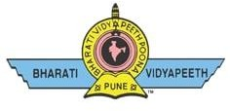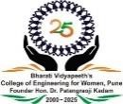
BHARATI VIDYAPEETH’S
COLLEGE OF ENGINEERING FOR WOMEN, PUNE
Pune-Satara Road, Dhankawadi, Taluka – Haveli, Dist.- Pune
Accredited by NAAC with “A” Grade, Affiliated to Savitribai Phule Pune University (SPPU) Approved by DTE. Govt. Of Maharashtra and AICTE, New Delhi
DTE Institute Code-EN6285, Pun Code-PU/PN/Engg. /150/2000
E-mail: -coewpune@bharatividyapeeth.edu Website: - http://coewpune.bharatividyapeeth.edu
Date: / / 2025
Ref. No.: BV/COEW/ /2025

India Today Ranking

Alumni Information

Name of Alumni | Contact Number | Currently Working at which organisation/Institute
Ms. Shital Sasane | 9763594024 | Ministry of Indian Railways
Ms. Shweta Vetal | 7447442575 | Komastu, Japan
Ms.Bhakti Jagtap | 7796208181 | Brightsea Technology Pvt. Ltd.,Pune
Ms. Namrata Jadhav | 9049796515 | Indian Airforce
Ms. Gayatri Zalwar | 7888045190 | Indian Navy Karwar Karnataka
Ms. Sailee Morde | 8796212413 | Accenture Ireland
Ms. Kritika Rai | 9130457401 | Walmart Global Technology Services
Ms.Utkarsha Kakade | 85528 71445 | Walmart Global Tech
Ms. Anushka Pandita | 6006083223 | Finance Department, Government of Jammu and Kashmir
Mrs. Mayuri Gavhane - Tilekar | 98220 87222 | Cadence Academy in the field of Fashion and Interior Designing, Pune
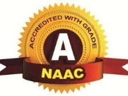

Prof. Dr. S. A. Pawar Prof. S. A. Sagar Prof. S. M. Thorat
Alumni Coordinator Alumni Coordinator Alumni Coordinator
(Comp. Dept.) (IT Dept.) (E&TC Engg.)

Prof. S. M. Thorat
Alumni Coordinator

